University of Nebraska – Lincoln

Department of Psychology

Center for Brain, Biology, and Behavior

Dr. Jeffrey Stevens

Treat & Train Retrofit Documentation and User Guide

17 May 2020

V1.4

**Overview**

The *PetSafe Treat & Train Manners Minder Remote Reward Dog Trainer* is a commercial, at-home tool for performing operant conditioning with your dog. Using an RF remote control, the dispensation of treats can be controlled by the user based on the settings indicated by the switch interface on the top of the device.

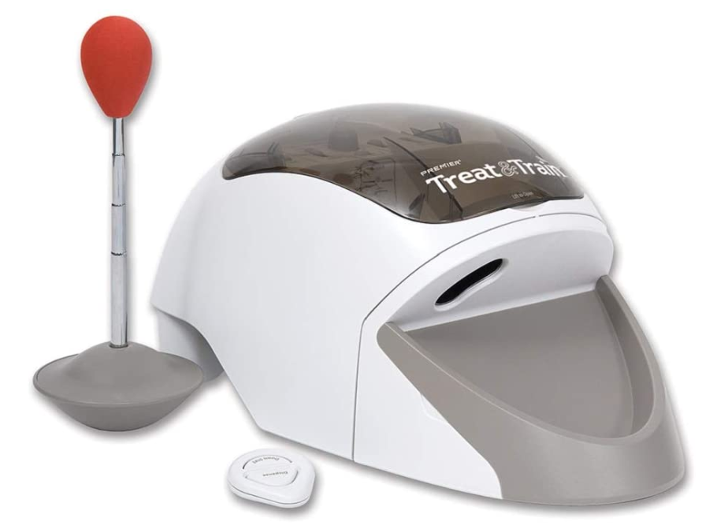

Figure 1 – Treat & Train Device

A main operation of the device is to train your dog to perform a “Down/Stay” command, which is facilitated by the dispensation of a pre-determined number of treats.

**Treat & Train Operation**

When the Treat & Train is operated in the single treat dispensation mode, meaning that a single treat is dispensed when the ‘Dispense’ button on the RF remote is clicked, it monitors two devices:

1. IR break sensor on the treat dispensing eyelet,
2. IR break sensor on an internal mirror locked to the rotation of the dispensing wheel.

There are two stop conditions for the dispensing wheel:

1. The eyelet break sensor is triggered,
2. The wheel performs a full rotation.

These two conditions are the main driving signals for operation of the device.

**Retrofitted Circuit Description**

The functionality of the Treat & Train was analyzed, and reverse engineered and reimplemented on a custom board, which allows for future expansion and software-based upgrades. The IR sensors that are used for the primary operation of the device are hooked up to resistor divider bridges to act as a voltmeter. The on-board motor driver interfaces to the main DC motor inside of the device. The motor output of the Treat & Train is hooked up to a transistor to detect when the main board is requesting a treat. The system voltage is boosted to 12V to drive the DC motor and the entire system operates off of the USB power input.

**Prototype Board**

Figure 2 – Working Circuit on Protoboard including Pinout

|  |  |  |  |
| --- | --- | --- | --- |
| **Pin Name** | **Arduino Pin** | **Function** | **Description** |
| Motor Output 2 | N/A | Output | Connected to negative motor pin |
| Motor Output 1 | N/A | Output | Connected to positive motor pin |
| IR LED Power | N/A | Output | 5V power supply for IR LEDs, current limited to 5mA |
| Ground | N/A | Input | Common ground pin |
| Wheel Sensor | A1 | Input | IR break sensor output from wheel sensor |
| Receiver Power | N/A | Output | 5V power supply for break sensors, current limited to 1mA |
| Treat Sensor | A3 | Input | IR break sensor from treat sensor |
| Click Input | 4 | Input | RF remote input for ‘Dispense’ button |

The on-board motor driver is connected to the Adafruit Metro Mini, which is an equivalent design to the Arduino Uno. The outputs from the Metro Mini are defined below.

|  |  |  |
| --- | --- | --- |
| **Pin Name** | **Arduino Pin** | **Description** |
| BIN1 | 9 | First input for motor driver, invert from other input to drive motor in one direction or the other. |
| BIN2 | 8 | Second input for motor driver, invert from other input to drive motor in one direction or the other. |
| PWMB | 6 | PWM input that controls the speed of the motor, accepts values between 0-255.  Default: 127 |

At this time, there is no working implementation using the wheel sensor.

When using the RF remote to trigger the system, **the Treat & Train main board must first be plugged in before plugging in the retrofitted board.**

Do not use anything other than a computer USB port for powering the system. The retrofitted board does not power the Treat & Train main board and the main device will still require four D cell batteries to operate.

**Custom Printed Circuit Board**

The custom board implements the functionality of the prior prototype board, with a fully integrated hardware solution.

Figure 3 – Custom Printed Circuit Board

|  |  |  |  |
| --- | --- | --- | --- |
| **Pin Name** | **Arduino Pin** | **Function** | **Description** |
| M+ | N/A | Output | Connected to positive motor pin |
| M- | N/A | Output | Connected to negative motor pin |
| GND | N/A | Input | Common ground pin |
| IR1 | N/A | Output | 3.3V power supply for IR LEDs, current limited to 5mA |
| IR2 | N/A | Output | 3.3V power supply for IR LEDs, current limited to 5mA |
| TRT | A1 | Input | IR break sensor from treat sensor |
| BRK | N/A | Output | 3.3V power supply for break sensors, current limited to 1mA |
| WHL | A3 | Input | IR break sensor output from wheel sensor |
| CLK | D8 | Input | RF remote input for ‘Dispense’ button |

|  |  |  |
| --- | --- | --- |
| **Pin Name** | **Arduino Pin** | **Description** |
| AIN1 | D7 | First input for motor driver, invert from other input to drive motor in one direction or the other. |
| AIN2 | D6 | Second input for motor driver, invert from other input to drive motor in one direction or the other. |
| PWMA | D3 | PWM input that controls the speed of the motor, accepts values between 0-255.  Default: 127 |

At this time, there is no working implementation using the wheel sensor.

When using the RF remote to trigger the system, **the Treat & Train main board must first be plugged in before plugging in the retrofitted board.**

Do not use anything other than a computer USB port for powering the system. The retrofitted board does not power the Treat & Train main board and the main device will still require four D cell batteries to operate. **This board shows up as the “Sparkfun Qwiic Micro” when seen in the Arduino IDE.**

**Schematic**



Figure 4 – First Page of the Electrical Schematic for the Custom Board



Figure 5 – Second Page of the Electrical Schematic for the Custom Board

**USB Protocol**

The system operates using a defined USB protocol driven by byte codes. This can be easily expanded upon in the firmware by adding cases to the switch statement for the command byte. This is defined below.

|  |  |  |
| --- | --- | --- |
| **Name** | **Value** | **Function** |
| Start Byte | 67 (Dec), 0x43, ‘C’ | Signals the system to start listening for input |
| Command Byte | 1 byte | Command defined below |
| Data Byte | 1 byte | Defined based on commands |
| End Byte | 69 (Dec), 0x45, ‘E’ | Signals the system to stop listening for input |

There are a few pre-defined commands for this version of the firmware, one of which is not accessible through USB input.

|  |  |  |  |
| --- | --- | --- | --- |
| **Command** | **Byte** | **Data** | **Function** |
| Dispense | ‘D’ | 0-9 (ASCII) | Command to dispense treats, the number of treats is between 0 and 9 in ASCII. |
| Print | ‘P’ | 0 (ASCII) | Prints current value of sensors, data field is set to zero in ASCII |
| Update RF | ‘B’ | 0-9 (ASCII) | Updates the number of treats dispensed when using the RF remote. |
| Dispense | ‘A’ | 0-255 (ASCII) | Command to dispense treats, the number of treats is interpreted as the hex value of the ASCII char for data |
| Motor Update | ‘M’ | 0-255 (ASCII) | Updates the motor speed used when operating the dispenser in any mode |
| Wheel Test | ‘F’ | 0 (ASCII) | Performs the wheel test routine to verify operation of the device and sensors |
| RF Dispense | N/A | N/A | By clicking the ‘Dispense’ button on the RF remote, the system will dispense the defined number of treats.  Default: 1 treat |

**Arduino Function Definitions**

/*

* Functionality test of the wheel movement and sensor outputs.

* No parameters or return values.

*/

void testWheel();

/*

* Prints out the current state of the IR sensors.

* No parameters or return values.

*/

void debugSensors();

/*

* Begins routine to dispense the number of treats specified.

* cycles - int, the number of treats to be dispensed.

* motorSpeed - int, the speed of the motor [0, 255].

* motorDir - bool, clockwise or counter-clockwise.

* isASCII - bool, if cycles is encoded as ASCII, then it will be converted to decimal.

* returns - bool, stops motor and returns True when complete.

*/

bool dispenseCommand(int cycles, int motorSpeed, bool motorDir, bool isASCII);

/*

* Converts a raw float value to a specified precision, i.e. 1.945 -> 1.95.

* raw - float, the raw floating point number to be converted.

* precision - int, the number of values after the decimal point.

* returns - float, converted float value.

*/

float roundFloat(float raw, int precision);

/*

* Returns the ADC reading from the specified pin after the specified number of samples.

* pin - int, the pin to be read from.

* samples - int, the number of times to average over before returning a value.

* returns - float, the raw floating point value of the pin, in volts.

*/

float getVoltage(int pin, int samples);

/*

* Function driven by getVoltage, returns the raw ADC reading averaged over the sampling period.

* pin - int, the pin to be read from.

* numReadings - int, the number of readings to average over.

* returns - int, raw, averaged ADC reading.

*/

int getAverageReading(int pin, int numReadings);

/*

* Function to move the dispenser wheel motor, at a specified speed and in a specified direction.

* motorSpeed - int, speed to move the motor at [0, 255].

* motorDir - bool, clockwise or counter-clockwise.

*/

void moveMotor(int motorSpeed, bool motorDir);

/*

* Deasserts the motor control lines.

* No parameters or return values.

*/

void stopMotor();

/*

* Initializes the pins specified in the file pins.h

* No parameters or return values.

*/

void initPins();

**Python Class Definition**

class CanineDispenser

**__init__**(comport_name='/dev/ttyACM0', delay=1)

Parameters: comport_name – device name, defaults to Linux device name

delay – period in seconds to delay to account for reset

**update_rf_amount**(num_treats)

Parameters: num_treats – the number of treats to dispense, int [0, 9]

Returns: 0 for success, 1 for failure, byte

**dispense_treats**(num_treats)

Parameters: num_treats – the number of treats to dispense, int [0, 9]

Returns: 0 for success, 1 for failure, byte

**dispense_treats_multi**(num_treats)

Parameters: num_treats – the number of treats to dispense, int [0, 255]

Returns: 0 for success, 1 for failure, byte

**change_motor_speed**(motor_speed)

Parameters: motor_speed – new motor speed, int [0, 255]

Returns: 0 for success, 1 for failure, byte

**debug_sensors**()

Returns: output line of the dispenser for state of sensors, str

**wheel_test**()

Returns: None. Outputs sensor information to command line

**disconnect**()

list_comports()

Returns: list containing serial objects that are available, list

read_dispenser_line(dispenser)

Parameters: dispenser – CanineDispenser object to operate on

Returns: string containing dispenser output, str

dispenser_test(expected_dispensers)

Parameters: expected_dispensers – number of dispensers to connect to, int

Returns: None. Outputs information to the command line

dispenser_functionality_test(comport_name)

Parameters: comport_name – string representing COM port to connect to

Returns: None. Outputs information to the command line

**Interfacing Example**

The retrofitted board can be interfaced using any modern system, but for this document Python 3.7 is used to interface to the system. A single library is needed, pySerial, which can be installed using Pip.

comports = list_comports()

dispensers = []

while expected_dispensers != 0:

try:

com_select = input("Select COM port from list above: ")

if int(com_select) < 0 or int(com_select) > len(comports) - 1:

print('Invalid input. Valid range is 0 to', len(comports) - 1)

else:

dispensers.append(CanineDispenser(comport_name=comports[int(com_select)].device))

expected_dispensers -= 1

except:

print('Invalid COM port selected, use numerals in range [0, 9]. Returning control.')

return

while True:

command = input('Enter number of treats to dispense [0, 9] or "exit" to quit: ')

try:

if command is 'exit':

for dispenser in dispensers:

dispenser.disconnect()

return

elif int(command) < 0 or int(command) > 9:

print('Invalid input. Valid range is [0, 9].')

else:

for dispenser in dispensers:

out = dispenser.dispense_treats(command)

if out == b'1':

print('Invalid command for', dispenser.comport.name)

elif out == b'0':

print('Successful command for', dispenser.comport.name)

except:

print('Invalid input. Only use numerals [0, 9] or type "exit". Returning control.')

return

Notice below that the new Treat & Train shows up as *USB Serial Device* on COM31.

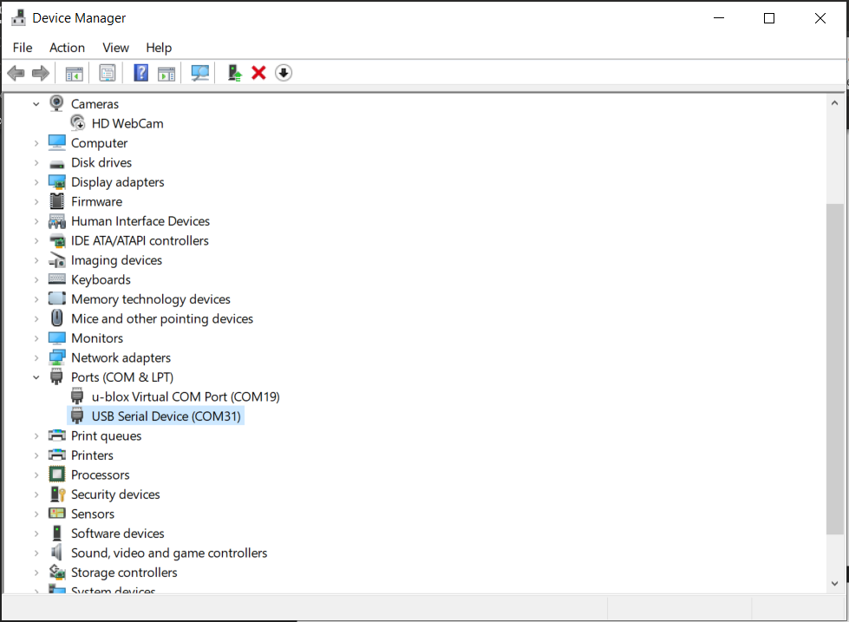

Figure 6 – USB Device Discovery in the Device Manager Tool

**Raspberry Pi 4 as an Experiment Platform**

The experiments on canine operant conditioning are run using a Python package called PsychoPy. It essentially acts as a development environment for psychology experiments and provides a variety of utilities for user interface development, trigger conditions, experiment logging, and so on. Our aim is to integrate this directly into a Raspberry Pi 4, to allow the entire setup to become a mobile testing unit. To do this, we will have a few requirements:

1. Wireless Access Point
   1. The Raspberry Pi 4 should host its own WiFi access point (AP), which allows the experimenter to connect to the Pi and run experiments, download results, and interact with the main system.
2. Decoupled Interfaces
   1. The screen the experimenter will use, and the screen used by the canine will be separate and require no extra hardware to achieve. By connecting to the Pi using SSH (Secure Shell), the command line can be exposed to run the experiments. The canine screen can be connected to the HDMI0 of the Pi and the SSH session can be started in a separate area.
3. Simple Setup
   1. We want to make sure this is easy to setup and maintain. This means that we would want to use robust packages such as ‘pi-ap’ and SD card backups to easily restore the device and get new devices up and running easily.

There are two ways to setup a new Raspberry Pi to operate the canine dispenser:

1. Flash a new SD card with an image from the iso_images folder
   1. Using a Raspberry Pi with a fresh installation of Raspbian Buster, there are built-in tools to achieve [this](https://www.raspberrypi.org/documentation/linux/filesystem/backup.md). “The SD Card Copier application, which can be found on the Accessories menu of the Raspberry Pi Desktop, will copy Raspbian from one card to another. To use it, you will need a USB SD card writer. To back up your existing Raspbian installation, put a blank SD card in your USB card writer and plug it into your Pi, and then launch SD Card Copier. In the ‘Copy From Device’ box, select the internal SD Card. This could have a number of different names and may have something like (/dev/mmcblk0) in its entry, but will usually be the first item in the list. Then select the USB card writer in the ‘Copy To Device’ box (where it will probably be the only device listed). Press ‘Start’. The copy, depending on the size of the SD card, can take ten or fifteen minutes, and when complete you should have a clone of your current installation on the new SD card. You can test it by putting the newly-copied card into the Pi’s SD card slot and booting it; it should boot and look exactly the same as your original installation, with all your data and applications intact.”
2. Follow the proceeding instructions to setup the Raspberry Pi manually.
   1. Flash a new copy of Rasbian Buster onto a micro SD card and place an empty file named “ssh” onto the boot partition. There is no file extension.
   2. Connect the Raspberry Pi to your local network using an Ethernet cable and power up the Pi. You can connect a monitor, keyboard, and mouse and use ifconfig to find the IP address of the Pi.
   3. Using this IP address, go to PuTTY and type in this IP address and connect to the Pi. The default password for “pi” is “raspberry”.
   4. Once in, the [pi-ap software](https://github.com/f1linux/pi-ap) can be installed to create the access point. Note, the dog_operant repository does contain a copy of this, but the main repository will contain the most recent version.
   5. The [dog_operant](https://github.com/adaptive-decision-making-lab/dog_operant) repository can be cloned using the git clone command.
   6. Run the command sudo apt-get update
   7. You will need to upgrade pip using   
      python3 -m pip install --upgrade pip   
      which will allow it to index some of the following packages.
   8. Run the command   
      python3 -m pip install psychopy==3.2.4   
      which will install all the needed packages. Using the older version of PsychoPy will prevent a ‘Segmentation fault’ caused when rendering a new Window.
   9. You may get an error saying that there is no package called ‘wx’, in which case you need to run the command   
      python3 -m pip install wxPython
   10. If you want to run experiments, you will need to connect a screen to the Pi on HDMI0. An issue may present itself where no screen is presented when connected, which is caused by an incorrect /boot/config.txt file. To fix this do the following:
       1. sudo nano /boot/config.txt
       2. Add the following to the file or uncomment from the file,
          1. hdmi_force_hotplug=1
          2. hdmi_drive=2
       3. If this does not fix the issue, add,
          1. hdmi_safe=1
   11. To run an experiment, use the following command   
       export DISPLAY=:0 ; python3 dog_operant/system_test.py   
       Note, this works from the command line, so run this when you are connected to an SSH session and with a screen connected to HDMI0 of the Pi and the experiment will display over HDMI0. Setting the DISPLAY variable to 0 will default it to the local display.
3. To transfer the results of the experiments, copy the contents of the data directory from the dog_operant directory. Use the following command structure:   
     
   scp -r user@ssh.example.com:/path/to/remote/source /path/to/local/destination

**Raspberry Pi Interfacing and Passwords**

The dispenser, when turned on, will create a WiFi access point called, “operant-canine-xx”, with “xx” being the number, i.e. “01”. By connecting to this, the Raspberry Pi can be accessed through SSH using a program called [PuTTY](https://www.chiark.greenend.org.uk/~sgtatham/putty/latest.html).

|  |  |
| --- | --- |
| Local Address | Password |
| pi@192.168.0.1 | cb3stevens |
| pi@adml-stevens-01 | cb3stevens |

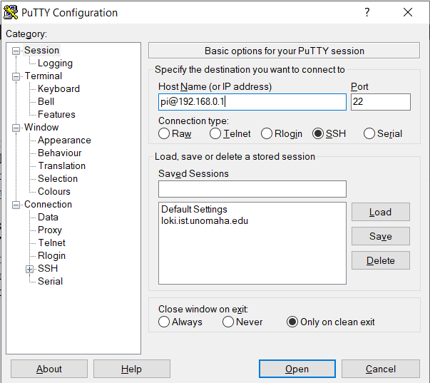

Figure 7 – PuTTY Terminal Configuration Window

**Bill of Materials**

*Printed Circuit Board Parts*



Table 1 – Bill of Materials for the Custom Board

*Build Parts*



Table 2 – Bill of Materials for the Treat & Train Retrofitting

**Build Instructions**

|  |  |
| --- | --- |
|  | 1. Flip the Treat & Train over and remove the five screws holding the bottom plate on. |
|  | 1. Next, flip the device over, open the treat reservoir and locate the two screws on the wheel face and remove them. Remove both this plate and the bottom plate, flipping over the device to expose the internal electronics. |
|  | 1. Observe the front exposed face and locate the black wire connected to the top IR receiver. This is marked in red. Cut it and solder on a new red wire approximately four inches in length. This is the output signal labeled ‘TRT’ on the custom board. |
|  | 1. Flip the device around and mark on the back face where the new electronics will be exposed. |
|  | 1. Now, observe the internal electronics of the stock device and notice the cord bundle on the top right of the device. Cut all of these except for the red and black power wires that go to the battery bank. Strip the ends of the cut wires and place them to the side. |
|  | 1. Next, tack on two wires to the shown pads on the underside of the internal board. The white wire will be our ‘Click’ signal and the black will be the common ground of the stock electronics. |
|  | 1. Bore out the marked ports on the back of the device and install the electronics using M3 screws. Eight will be required of the 12mm variety. Additionally, notice the teeth on the inner wall of the bottom plate. Clip these off using flush cutters as the installed electronics will get in the way of them. |
|  | 1. Now, install the wires from the internals of the device to the custom board shown. |
|  | 1. Note, for this build we used as custom a Raspberry Pi, right angle mounting plate. Now, connect the associated wires to Pi. |
|  | 1. Screw the device back together and plug in the short USB cable from the Pi to the custom board. |

**Reliability Testing**

For this testing, we wanted to see the failure rate of the dispensing commands, meaning the amount over or under that is dispenses from the target amount. To do this, we performed a total of one-hundred tests split into ten tests of increasing dispensing targets from one to ten treats, in steps of one treat. These tests were performed using two of the described dispensers, which were filled up to the “1 cup” line with Pet Botanics Training Reward treats, which are cylindrical treats that fit through the larger dispenser wheel.

The results for this testing are shown below in Table 3.



Table 3 – Results of the Reliability Testing

As shown above, the average error between the two dispensers is 28%, which is an error every fourth dispensation command. This error happens when two treats stack in the output hole and when it dispenses, both fall through, leading to dispensing one extra treat. If, for instance, a circular or thicker treat was used, this issue could be mitigated.

**Firmware**

*pins.h*

#define MDRIVERA 7

#define MDRIVERB 6

#define MSPEED 3

#define CLICK 8

#define WHEEL_SENSOR A3

#define TREAT_SENSOR A1

*TreatAndTrainDriverCustomBoard.ino*

/*

* Treat & Train Custom Driver

* Author: Walker Arce, May 2020

*

* This program is used to drive the Treat & Train device for pellet dispensation.

* It operates using a simple USB command protocol and can also be driven by the use of the

* accompanying RF remote.

*

* The current operation of the system is as follows:

* 1. A command is sent over USB to dispense a pellet,

* a. Drives wheel until pellet sensor is broken or wheel goes a full rotation.

* 2. The button 'Dispense' is clicked on the RF remote

* a. Drives wheel until pellet sensor is broken or wheel goes a full rotation.

*

* The motor can be driven at a variety of levels, for the second state of operation, it will be driven at half speed (6V DC).

*

* This initial version is meant to simply replicate functionality. The Treat & Train can be restored to original functionality

* by reconnecting the internal board and sensors.

*

* v0.3

* 12 May 2020

*/

#include "pins.h"

#define Serial SerialUSB

#define SerialDebug false

#define VOLTAGE_SCALE 3.3

#define ADC_PRECISION 4096.0

#define LOGIC_LOW 0.09

//Voltage sensing variables

float Vout = 0.00;

float Vin = 0.00;

float R1 = 1000000.00; // resistance of R1 (1M)

float R2 = 1000000.00; // resistance of R2 (1M)

//Peripheral sampling variables

float sampleVoltage = 0;

float wheelVoltage = 0;

float treatVoltage = 0;

int clickSignal = 0;

int clickCycles = 1;

int globalMotorSpeed = 127;

void setup()

{

Serial.begin(9600);

analogReadResolution(12); // Set analog input resolution to max, 12-bits

initPins();

stopMotor();

//while(1){ debugSensors(); }

//moveMotor(125, true);

}

void loop()

{

//Listen for the RF remote

if (digitalRead(CLICK) == HIGH)

{

if(dispenseCommand(clickCycles, 127, false, false))

{

Serial.println("Successfully dispensed");

}

else

{

Serial.println("Error occurred");

}

while(digitalRead(CLICK) == HIGH) {}

}

//Wait for USB input

while(Serial.available() > 0)

{

char command[4];

size_t bytesRead = Serial.readBytes(command, 4);

//Check for 'C' being sent

if (command[0] == 67 && command[3] == 69)

{

switch(command[1])

{

//Check for 'D' being sent

//This dispenses the specified number of treats, give or take.

case 68:

if (dispenseCommand(command[2], globalMotorSpeed, false, true))

{

Serial.print(0x00, HEX);

}

else

{

Serial.print(0x01, HEX);

}

break;

//Check for 'P' being sent

//This prints out the current state of the internal sensors.

case 80:

debugSensors();

break;

//Check for 'B' being sent

//This updates the number of treats dispensed when RF remote is clicked

case 66:

clickCycles = command[2] - 0x30;

Serial.print(0x00, HEX);

break;

//Check for 'A' being sent

//This is meant to be used when more than nine treats are expected to be dispensed

//Does not convert ASCII character to decimal

case 65:

if (dispenseCommand(command[2], globalMotorSpeed, false, false))

{

Serial.print(0x00, HEX);

}

else

{

Serial.print(0x01, HEX);

}

break;

//Check for 'M' being sent

//This allows the changing of the global motor speed

//Not recommended to be used

case 77:

globalMotorSpeed = command[2];

Serial.print(0x00, HEX);

break;

//Command not recognized

default:

Serial.print(0x01, HEX);

}

}

else

{

Serial.print(0x01, HEX);

}

}

}

void testWheel()

{

int motorSpeed = 0;

while(motorSpeed < globalMotorSpeed)

{

moveMotor(motorSpeed++, true);

wheelVoltage = getVoltage(WHEEL_SENSOR, 10);

wheelVoltage = roundFloat(wheelVoltage, 1);

treatVoltage = getVoltage(TREAT_SENSOR, 10);

treatVoltage = roundFloat(treatVoltage, 1);

Serial.print("Wheel Voltage: ");

Serial.print(wheelVoltage);

Serial.print("V | Treat Voltage: ");

Serial.print(treatVoltage);

Serial.print("V");

Serial.print(" | Speed: ");

Serial.print(motorSpeed);

Serial.println();

delay(200);

}

stopMotor();

}

void debugSensors()

{

moveMotor(127, true);

wheelVoltage = getVoltage(WHEEL_SENSOR, 10);

wheelVoltage = roundFloat(wheelVoltage, 1);

treatVoltage = getVoltage(TREAT_SENSOR, 10);

treatVoltage = roundFloat(treatVoltage, 1);

Serial.print("Wheel Voltage: ");

Serial.print(wheelVoltage);

Serial.print("V | Treat Voltage: ");

Serial.print(treatVoltage);

Serial.print("V");

Serial.println();

delay(200);

}

bool dispenseCommand(int cycles, int motorSpeed, bool motorDir, bool isASCII)

{

sampleVoltage = getVoltage(TREAT_SENSOR, 10);

sampleVoltage = roundFloat(sampleVoltage, 1);

int treatSamples = cycles;

if (isASCII) { treatSamples = cycles - 0x30; }

int wheelSamples = treatSamples * 3;

moveMotor(motorSpeed, motorDir);

while (treatSamples > 0)

{

treatVoltage = getVoltage(TREAT_SENSOR, 10);

treatVoltage = roundFloat(treatVoltage, 1);

if (treatVoltage < sampleVoltage)

{

treatSamples--;

while (treatVoltage < sampleVoltage)

{

treatVoltage = getVoltage(TREAT_SENSOR, 10);

treatVoltage = roundFloat(treatVoltage, 1);

}

}

}

stopMotor();

return true;

}

//Source: https://stackoverflow.com/questions/1343890/how-do-i-restrict-a-float-value-to-only-two-places-after-the-decimal-point-in-c

float roundFloat(float raw, int precision)

{

return floorf(raw * (10 * precision)) / 10;

}

//Source: https://create.arduino.cc/projecthub/next-tech-lab/voltmeter-using-arduino-00e7d1

float getVoltage(int pin, int samples)

{

int val = getAverageReading(pin, samples);

Vout = (val * VOLTAGE_SCALE) / ADC_PRECISION; // formula for calculating voltage out i.e. V+, here 5.00

Vin = Vout / (R2/(R1+R2)); // formula for calculating voltage in i.e. GND

if (Vin < LOGIC_LOW)//condition

{

Vin=0.00;

}

return Vin;

}

int getAverageReading(int pin, int numReadings)

{

int adcReading = 0;

for (int i = 0; i < numReadings; i++)

{

adcReading += analogRead(pin);

}

adcReading /= numReadings;

return adcReading;

}

void moveMotor(int motorSpeed, bool motorDir)

{

//Set motor speed before driving motor

analogWrite(MSPEED, motorSpeed);

//If true, then drive it clockwise

if (motorDir)

{

digitalWrite(MDRIVERA, HIGH);

digitalWrite(MDRIVERB, LOW);

}

//If false, then drive it counter-clockwise

else

{

digitalWrite(MDRIVERA, LOW);

digitalWrite(MDRIVERB, HIGH);

}

}

void stopMotor()

{

analogWrite(MSPEED, 0);

digitalWrite(MDRIVERA, LOW);

digitalWrite(MDRIVERB, LOW);

}

void initPins()

{

//Initialize inputs

pinMode(WHEEL_SENSOR, INPUT);

pinMode(TREAT_SENSOR, INPUT);

pinMode(CLICK, INPUT);

//Initialize outputs

pinMode(MDRIVERA, OUTPUT);

pinMode(MDRIVERB, OUTPUT);

pinMode(MSPEED, OUTPUT);

}

*dispenser_utilities.py*

"""dispenser_utilities.py

This script creates a serial interface to the retrofitted Treat & Train device developed

for Dr. Jeffrey Stevens' canine operant conditioning studies. The member methods

comply with the USB protocol developed to interact with its internal state machine

and encapsulates a comport definition and a configurable delay period.

Supported device operations include (replace X with relevant value):

Dispense treats in [0, 9] range: CDXE

Dispense treats in [0, 255] range: CAXE

Update the RF remote dispensation amount in range [0, 9]: CBXE

Update motor speed in range [0, 255]: CMXE

Debug sensors: CP0E

Wheel test routine: CF0E

Note: The value placed in X will be represented in ASCII, so for the 'D' command it will be valid in ASCII range

[0, 9], in which case the device will convert the value passed from ASCII to decimal. In the case of the 'A'

command, it treats the ASCII value as the number of treats and does not convert the value to decimal.

Supports version 0.4 of the dispenser firmware.

Author: Walker Arce

Date: 05/17/2020

Version: 0.3

"""

import serial

import serial.tools.list_ports

import time

class CanineDispenser:

"""A simple class definition to interact with the canine treat dispenser.

self.comport - pyserial USB port object used to communicate with the device.

self.delay - period in seconds to wait before sending command to allow for reset.

"""

def __init__(self, comport_name='/dev/ttyACM0', delay=1):

"""

Parameters

:param comport_name: str

The name of the USB port to connect to, i.e. '/dev/ttyACM0' or 'COM31'

:param delay: int or float

The period in seconds to wait before sending command to allow for reset

"""

try:

self.comport = serial.Serial(comport_name, baudrate=9600, timeout=None)

self.delay = delay

except serial.SerialException:

print('Failed to open serial port, double check port and try again.')

print('Port: ' + comport_name)

def update_rf_amount(self, num_treats):

"""Sends a command to the dispenser to update the number of treats dispensed when using the RF remote.

Parameters

:param num_treats: int

The number of treats in range [0, 9] to dispense

:return: byte

0 for success, 1 for failure

"""

if num_treats < 0 or num_treats > 9:

print('Number of treats must be within range [0, 9], please retry.')

return

if self.comport.isOpen():

command = 'CB'.encode('ascii') + str(num_treats).encode('ascii') + 'E'.encode('ascii')

time.sleep(self.delay)

self.comport.write(command)

return self.comport.read(1)

def dispense_treats(self, num_treats):

"""Sends command to dispense treats in range [0, 9]

Parameters

:param num_treats: int

The number of treats in range [0, 9] to dispense

:return: byte

0 for success, 1 for failure

"""

if int(num_treats) < 0 or int(num_treats) > 9:

print('Number of treats must be within range [0, 9], please retry. '

'Use dispense_treats_multi to dispense more treats.')

return

if self.comport.isOpen():

command = 'CD'.encode('ascii') + str(num_treats).encode('ascii') + 'E'.encode('ascii')

time.sleep(self.delay)

self.comport.write(command)

else:

print('No open comport on this object.')

return

return self.comport.read(1)

def dispense_treats_multi(self, num_treats):

"""Sends command to dispense a greater amount of treats, in range [0, 255]

Parameters

:param num_treats: int

The number of treats to dispense in range [0, 255]

:return: byte

0 for success, 1 for failure

"""

if int(num_treats) < 0 or int(num_treats) > 255:

print('Number of treats must be within range [0, 255], please retry.')

return

if self.comport.isOpen():

command = 'CA'.encode('ascii') + chr(num_treats).encode('ascii') + 'E'.encode('ascii')

time.sleep(self.delay)

self.comport.write(command)

return self.comport.read(1)

def change_motor_speed(self, motor_speed):

"""Sends command to update the motor speed with provided value in range [0, 255]

Note: Increasing the motor speed beyond 127 (default) is not recommended for expected use case.

Parameters

:param motor_speed: int

Speed of the motor in range [0, 255] or [0V, 12V] equivalent

:return: byte

0 for success, 1 for failure

"""

if motor_speed < 0 or motor_speed > 255:

print('Motor speed must be within valid range [0, 255], please retry.')

return

if self.comport.isOpen():

command = 'CM'.encode('ascii') + chr(motor_speed).encode('ascii') + 'E'.encode('ascii')

time.sleep(self.delay)

self.comport.write(command)

return self.comport.read(1)

def debug_sensors(self):

"""Sends command to get the current state of the sensors, used for debugging sensor issues

:return: str

String representing the current value of the sensors

"""

if self.comport.isOpen():

self.comport.write('CP0E'.encode('ascii'))

return read_dispenser_line(self)

def wheel_test(self):

"""Sends command to run the wheel test procedure

Try breaking the eyelet sensor to verify operation or updating the motor speed to change the max speed

:return: None

Loop is terminated by the dispenser sending a '0' for successful completion

"""

if self.comport.isOpen():

self.comport.write('CF0E'.encode('ascii'))

wheel_out = ""

while wheel_out != b'0':

wheel_out = read_dispenser_line(self)

if wheel_out[-3:] != '127':

print(wheel_out)

elif wheel_out[-3:] == '127':

print(wheel_out)

wheel_out = self.comport.read(1)

def disconnect(self):

"""Disconnects the internal comport object.

:return: none

"""

self.comport.close()

def list_comports():

"""Wrapper utility to show exposed COM ports.

:return: list

List consisting of serial object representing the available COM ports

"""

comports = serial.tools.list_ports.comports()

print([comport.device for comport in comports])

return comports

def read_dispenser_line(dispenser):

"""Wrapper function on serial.readline() function to handle Arduino Serial.println(). Use in loop to handle

continuous output.

Source: https://stackoverflow.com/questions/24074914/python-to-arduino-serial-read-write

:param dispenser: CanineDispenser

Pass a dispenser object with an open comport

:return: str

Trimmed Arduino output string

"""

line_out = str(dispenser.comport.readline())

return line_out[2:][:-5]

def dispenser_test(expected_dispensers):

"""This function is to be used to test multiple dispensers for basic functionality

Parameters

:param expected_dispensers: int

The number of dispensers to be connected to

:return: None

Used to break while loop, returns None value

"""

comports = list_comports()

dispensers = []

while expected_dispensers != 0:

try:

com_select = input("Select COM port from list above: ")

if int(com_select) < 0 or int(com_select) > len(comports) - 1:

print('Invalid input. Valid range is 0 to', len(comports) - 1)

else:

dispensers.append(CanineDispenser(comport_name=comports[int(com_select)].device))

expected_dispensers -= 1

except:

print('Invalid COM port selected, use numerals in range [0, 9]. Returning control.')

return

while True:

command = input('Enter number of treats to dispense [0, 9] or "exit" to quit: ')

try:

if command is 'exit':

for dispenser in dispensers:

dispenser.disconnect()

return

elif int(command) < 0 or int(command) > 9:

print('Invalid input. Valid range is [0, 9].')

else:

for dispenser in dispensers:

out = dispenser.dispense_treats(command)

if out == b'1':

print('Invalid command for', dispenser.comport.name)

elif out == b'0':

print('Successful command for', dispenser.comport.name)

except:

print('Invalid input. Only use numerals [0, 9] or type "exit". Returning control.')

return

def dispenser_functionality_test(comport_name):

"""Sends all commands that return a byte return code.

Parameters

:param comport_name: str

Name of the COM port, i.e. '/dev/ttyACM0' or 'COM31'

:return: None

Prints state of the commands to command line

"""

dispenser = CanineDispenser(comport_name=comport_name)

D_out = dispenser.dispense_treats(1)

A_out = dispenser.dispense_treats_multi(1)

M_out = dispenser.change_motor_speed(127)

RF_out = dispenser.update_rf_amount(1)

if D_out == b'0' and A_out == b'0' and M_out == b'0' and RF_out == b'0':

print('D: ', D_out, '\nA: ', A_out, '\nM: ', M_out, '\nRF: ', RF_out, '\nDispenser operating successfully.')

else:

print('D: ', D_out, '\nA: ', A_out, '\nM: ', M_out, '\nRF: ', RF_out, '\nDispenser not operating correctly.')

**Document Revision History**

|  |  |
| --- | --- |
| Revision, Name, and Date | Revision Description |
| V0.1, Walker Arce, 21 March 2020 | First draft creation date for Treat & Train retrofitted circuit. |
| V1.0, Walker Arce, 27 April 2020 | Added documentation on custom board |
| V1.1, Walker Arce, 28 April 2020 | Added documentation on updated software |
| V1.2, Walker Arce, 12 May 2020 | Added docs on new commands and Raspberry Pi |
| V1.3, Walker Arce, 16 May 2020 | Added build instructions and bills of material |
| V1.4, Walker Arce, 17 May 2020 | Added Python source, updated interfacing, and commands |